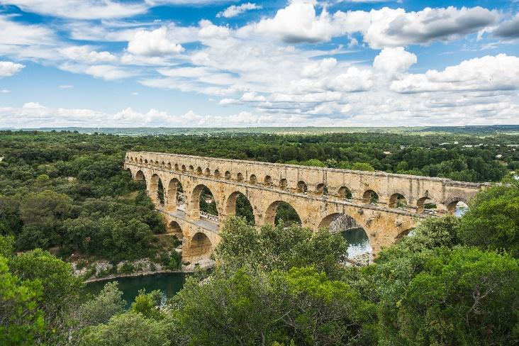

**English:** As writers we will be developing our writing skills, looking at how to write a detailed report and then in the last half term writing our own story book for a year R child. Our work on Spelling, punctuation and grammar will continue and we will be undertaking more challenging comprehension papers. The Free Readers have enjoyed compiling a Newspaper…I wonder what they will want to tackle next!?

**P.E.** There will be a variety of sports this term, with the Young Leaders continuing to play an important role and weekly swimming becoming part of our last half term’s activities…as well as preparing for Sports Day.

**Science** As scientists we will be spending half the term looking at Plants and the other half term studying LIGHT which will include creating a Shadow Puppet play. As usual this will include learning how to work scientifically including: planning investigations, drawing tables and discussing fair testing. The Continuous Provision table will provide opportunities for each child to have time to explore each area in greater depth, for example, comparing the difference between primary and secondary colours in paint compared with those in light.

**Badgers Class Curriculum Plan**

**Summer 2023**

**Maths:** As mathematicians we will focus on gaining a clear understanding of data, time, measure and money whilst perfecting fractions and decimals. We will recap our work on adding, subtracting, multiplying and dividing and aim to become proficient at problem solving.

**Foundation Subjects**

As **historians** we will be looking at the Roman invasion of Britain and how they brought engineering skills with them.

In **music** we will on two different projects, one is composing using only three notes and then we move onto Samba! We will also be working on our Viking Musical.

In **I.C.T.** we will continue with e safety and programming and using ICT to enhance our work across other curriculum areas. We will continue to work on our touch typing and programming.

**In P.S.H.C.E**, we will look at changes and prepare for the move to our next year groups, which is slowly creeping nearer!

**R.E.** sees us looking at the Jewish festivals and then progressing onto looking at festivals in general. We will discuss symbols and the meaning of the word ritual.